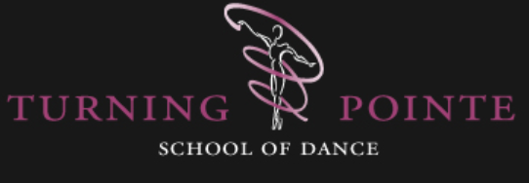
Child Protection and Safeguarding Policy

Turning Pointe School of Dance (TPSD) believes that:
The welfare of children and vulnerable people is paramount.
All the members of our community, irrespective of age, culture, disability, gender, religion or racial origin, have the right to:
- Protection from harm;
- Provision of safe and effective care, which enables the best outcomes for each individual.
If any member of the TPSD community should have concerns regarding the welfare of any child under our care, it should be reported immediately to our Child Protection Officer, Carmel Keller (turningpointecarmel@gmail.com). If the concern involves the Child Protection Officer, or if the reporting party feels that the concerns have not been appropriately addressed, local Children’s Services should be contacted.
In order to uphold our Child Protection and Safeguarding Policy, TPSD will ensure that:
- Appropriate checks are undertaken on all staff. These will be recorded in a secure manner by the Assistant Principal.
- All staff are aware of signs of child protection issues and know where to report any concerns.
- That physical contact with students is always appropriate and never in a closed environment. Dance is a physical activity and a teacher will sometimes need to give manual/physical corrections and/or assistance. This should always be given openly and professionally, maintaining the student’s best interests. Young people should always be consulted and their agreement gained. Any sensitivities raised but a student/guardian concerning the manual correction of a student should be noted and respected.
- Teachers treat all students with respect and dignity, irrespective of age, culture, disability, gender, religion or racial origin.
- All teachers adhere to the Staff Code of Conduct, which is available to view on the TPSD website (www.turningpointedanceschool.co.uk).
- Endeavour to ensure that all classes are conducted in open environments. Parents/guardians are not permitted into the studio environment, unless for watching days, or by prior consent of the Principal or teacher. However, there should always be a window or door through which teaching can be observed. Studio doors should never be locked, unless in an exceptional circumstance where this may be necessary for student safety.
- Where possible one adult should not be left to supervise changing areas alone. Where this is not possible, the adult in question should be DBS checked, should not be left alone for longer than necessary and no doors should be locked.
- Photographs and videos taken or acquired by the school are only used with the permission of parents/guardians, and only in an official school capacity. A child’s right to refuse such permission irrespective of parental consent should always be respected. Permission to use such images may be withdrawn at any time.
- If photographs or videos are taken for training purposes, these will be kept securely and not shared over social media.
- Parents/guardians are welcome to take videos and photographs of their own child at open classes and other events, unless otherwise stipulated. Where possible these images should avoid capturing other children, and if there are other children in the photographs or videos, these should under no circumstances be shared on social media. Any parent/guardian with concerns about this should contact the school Principal (turningpointelianne@outlook.com).
Last updated by Nisa Carter, July 2022

